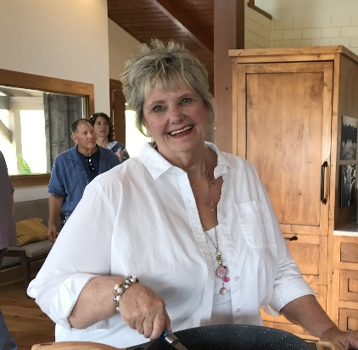

I am an imperfect disciple, a Mom, Daughter, Sister, Grandmother, Mother-in-law, Retired, Friend, Teacher, Student, Speaker, Seeker and Lover of Life. Coastal Bend in Texas is my Mission Center where I hold the priesthood office of Evangelist. I graduated from the University of Hard Knocks with a degree in Life Skills that I continually work to develop new understandings of God generous Grace. I am thrilled to be coming to Camp Bountiful! Come with openness to listen for God in nature, while meeting new friends and exploring new possibilities.

